Kernel SVM intuition – What happens when we cannot find the boundary? Not Linearly Separable

Mapping to a higher dimension Non linearly separable dataset and increase the dimension

Apply

F = x -5

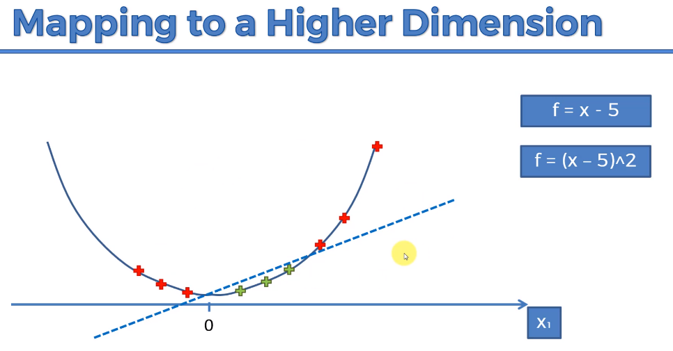F = (x-5)2

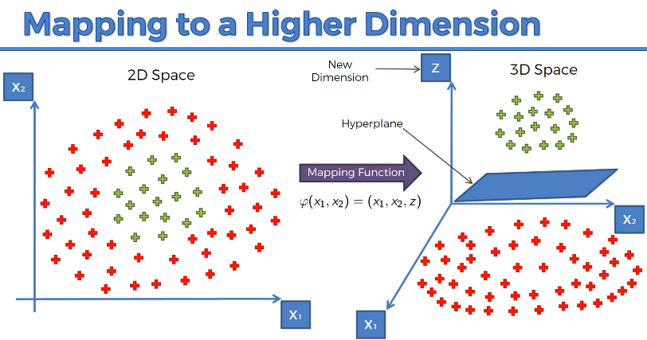Then Project everything back to our original space.

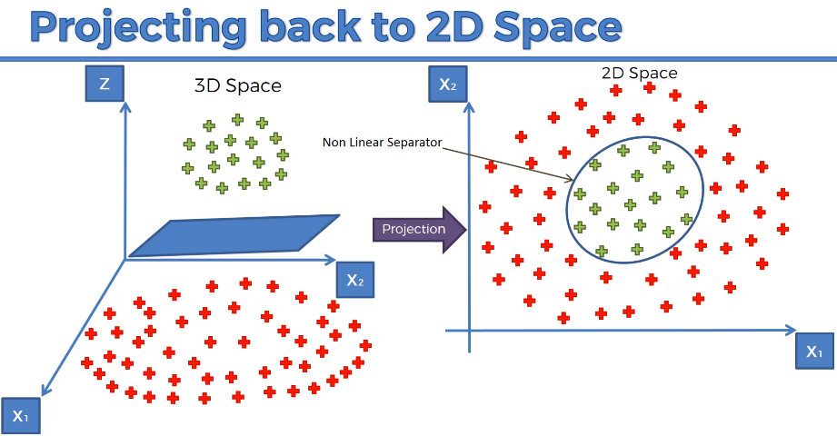Mapping to a higher Dimensional space can be highly compute-intensive

THE KERNEL TRICK

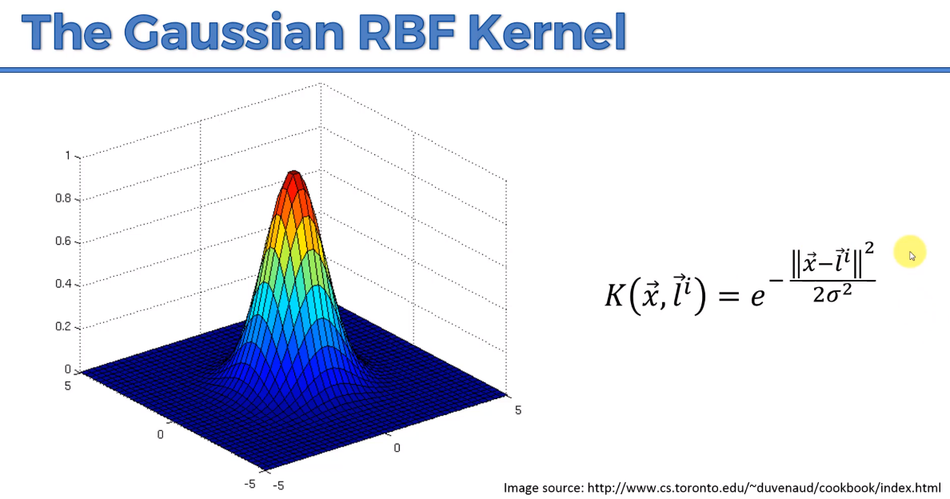Gaussian RBF Kernel –

K – Kernel

X vector – Point in our data set

Li – Landmarks, i – several landmarks

||x - i|| - Distance between the landmarks square and divided by 2 sigma2

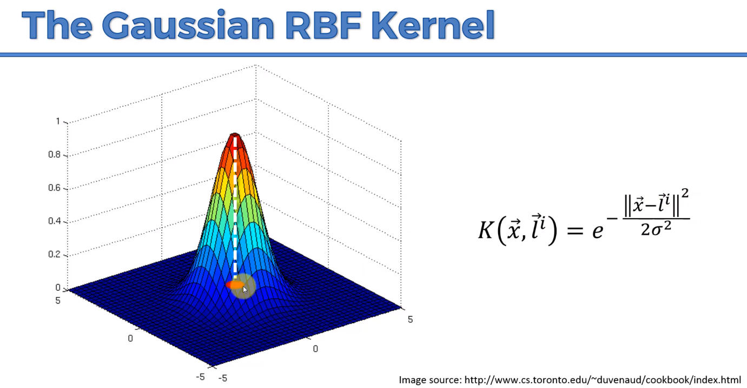L is in the middle of the plane where x = 0 , y = 0. Vertical axis represent the result you get after applying the formula.

Distance is a Large number, e-Large number will give you a value that is very close to Zero. When you are far away from the landmark, you get zero vertical.

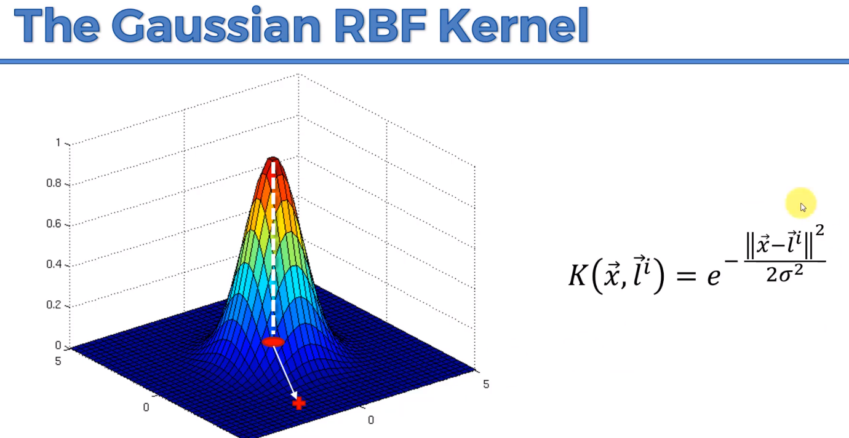If you are at a small number, e-small number will give you a value that will converge to one. When you are nearer and near the vertical value will be closer to one.

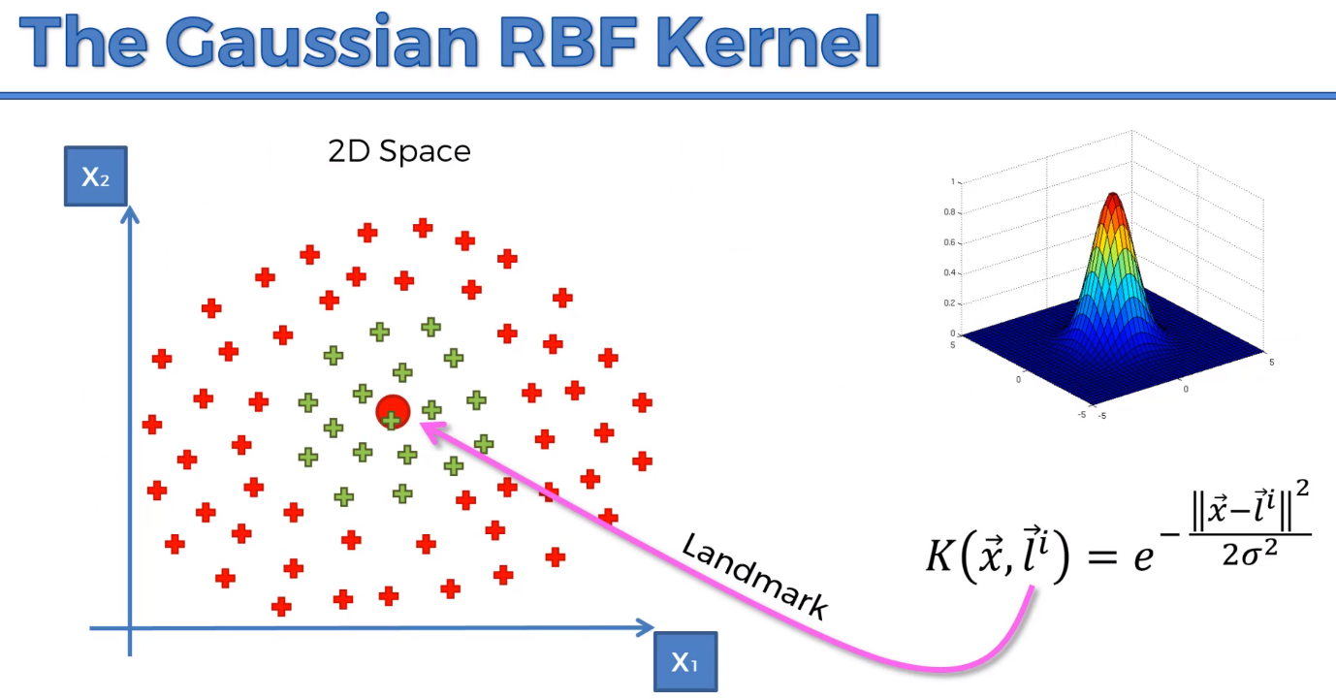We need to use the function to separate the boundary. There is away to find the optimal place for the landmark.

SIGMA is the circumference of the circle,

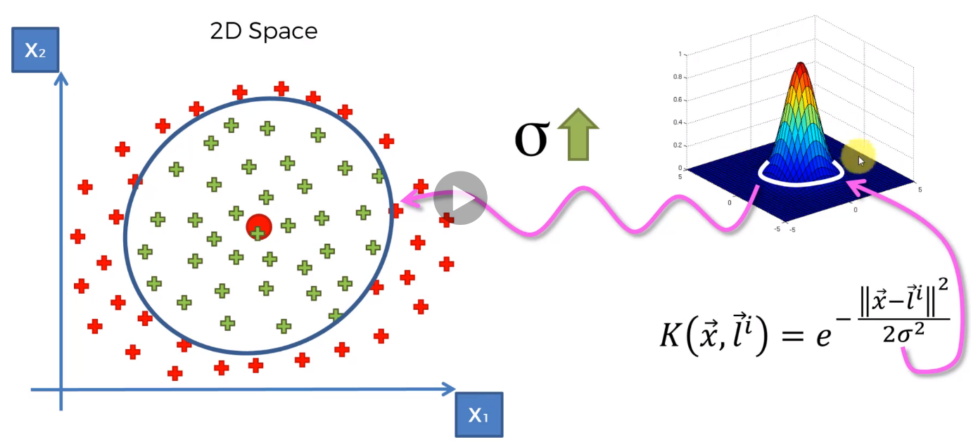Need to find the Right Sigma, to find the correct function to assign Zero function to things you don’t want. Mapping Function. We are still doing computation in the lower dimensional space.

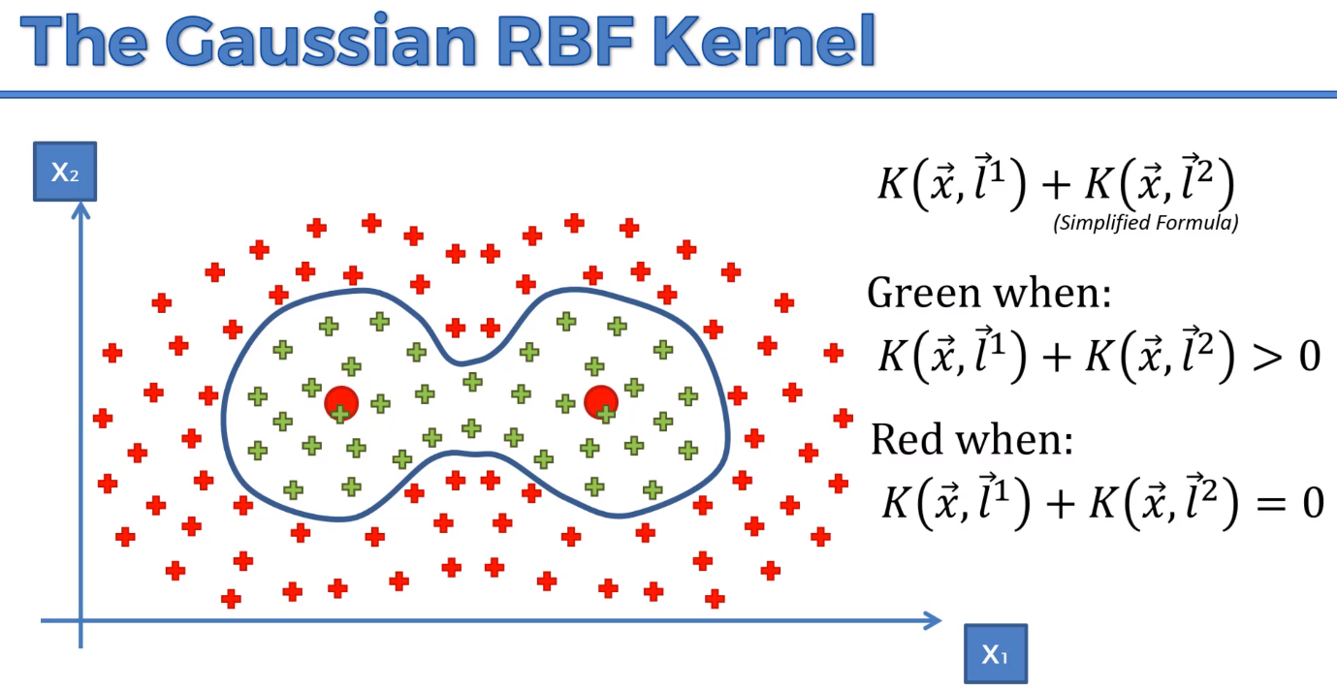

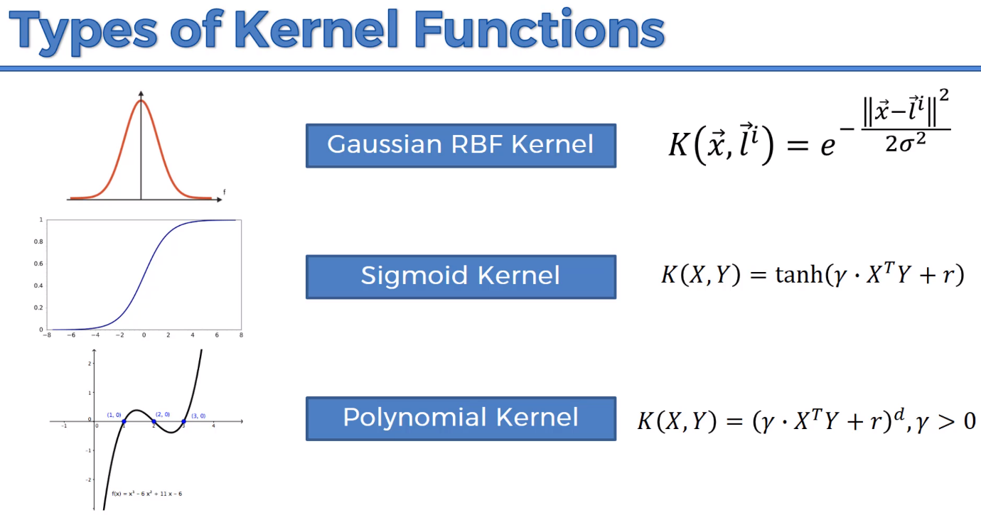Types of Kernel Functions

mlkernels.readthedocs.io/en/latest/kernelfunctions.html

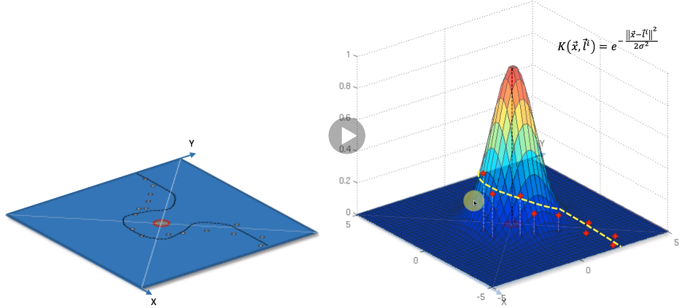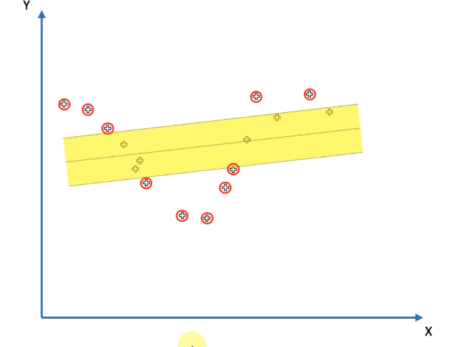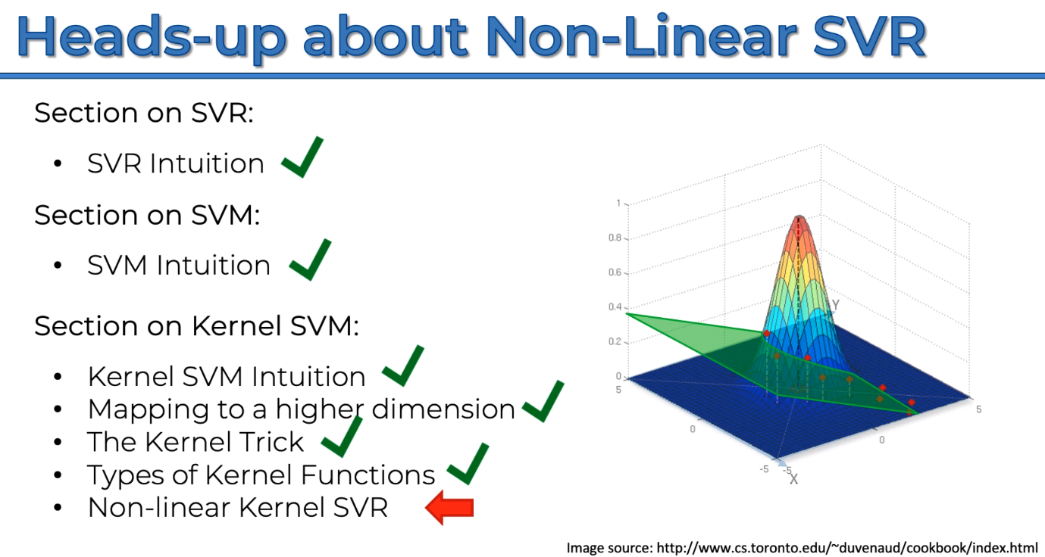 Non-Linear SVM Intuition

Find where does it intersect between the Kernel and the Hyper plane and then and find the line. Yellow dotted line and then cast it into the 2d Plane

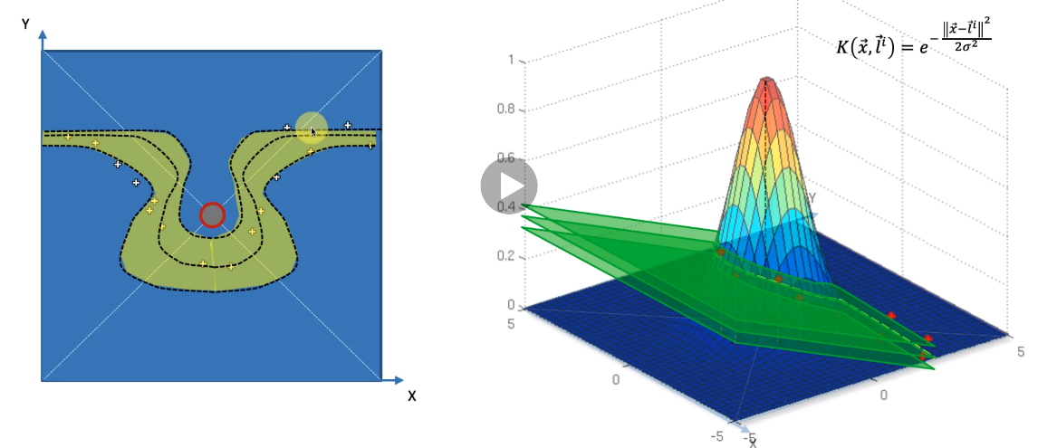The epslon wil be above and below the plane. And cast it into the 2d Plane.

Everything is illustrative purposes,